Dinosaur Game

## Game Outline:

Your task is to design and build a jumping dinosaur game using the lab-kit components, somewhat similar to this:

<https://drive.google.com/file/d/1AJ2XwomKsZTmlfIHSFG6JsTn1LT-lkLy/view?usp=sharing>

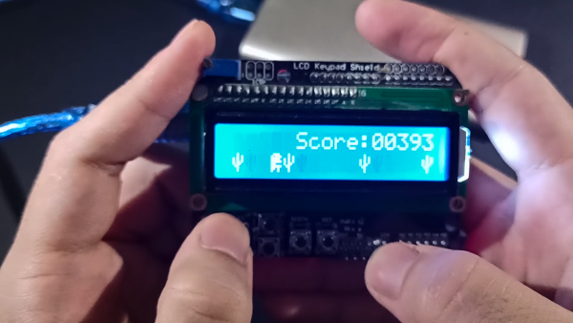

## Requirements:

1. The game should start with a splash screen.
2. Next, the game should prompt the user to enter a username:

Users should be able to enter a user name using the keypad.

* 1. The user should be able to enter a five-character username and it should be displayed on the LCD while being entered.
  2. Then, after entering the user name, pressing the # symbol should send the username to the PC (serial monitor) with the message

“User: <username>”

1. The game screen should advance to the menu:  
   The menu should contain options to 1) start the game; 2) change difficulty; 3) change audio volume; 4) edit user name; 5) High-Scores Leaderboard. You may include additional options of your choice. The keypad should be used to navigate the menu, use suitable keys for this. Use the # key to confirm the selected option.
2. Once the game is started:  
   Use a push button to make the “dinosaur” jump to avoid the obstacles. You should generate obstacles similar to the video above. If the dinosaur collides with an obstacle, the game is over.
   1. Come up with your own algorithm for obstacle generation.
   2. Create your own graphics for the dinosaur figure, and for the obstacles.
   3. Add sound effects.
   4. Come up with a scoring system for the number of successful jumps.
   5. Design ways to increase difficulty, based on the difficulty level selected from the menu (ex: change the speed based on the selected difficulty, change the maximum size of obstacles, etc.). You may decide the number of difficulty levels.
3. The game score should be displayed on PC/Desktop during the gameplay (serial communication).
4. When the game is over, signal the user using a buzzer sound and a game-over screen showing the score. Send a game-over message with the score to the PC (serial monitor).  
   If the score is the highest on the leaderboard, include an additional message on-screen as well as on the PC.
5. Maintain a High-Scores leaderboard for users that can be selected from the menu, using the EEPROM to store the top ten scores.
6. Add a menu item to control the LCD brightness using PWM.
7. Create a custom delay function to be used in your code using timers (do not use in-built delay functions).

Components:

* Keypad
* LCD
* Arduino UNO
* USB connector
* Breadboard
* Push Button
* Buzzer
* Jumper Cables
* Resistors

## General Instructions:

* You will be working in groups of two.
* Coding must be done using the C language.
* You are supposed to implement all the functionalities specified above. The marks will be awarded as per the functionalities completed.

## Timeline:

1. Week 4: Menu system with keypad and LCD
2. Week 7: Add timing and include the actual game + splash screen
3. Week 8: Add sound and other features
4. Week 9: Add game to PC communication